Pi Setup

Kevin Eaton

1. Sensors Setup
   * This is a general diagram on where everything should be

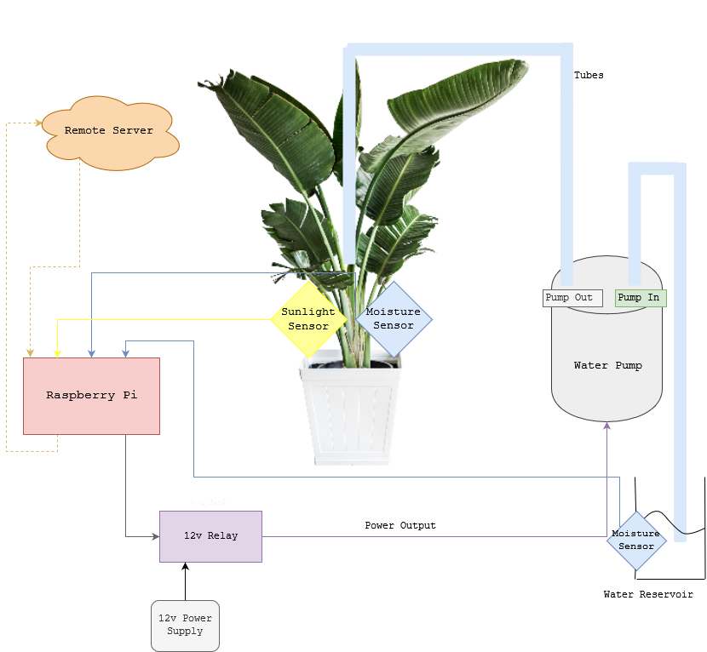

1. Moisture Sensor
   * Help from: <https://www.instructables.com/ADC-MCP3008-Raspberry-Pi/>
   * 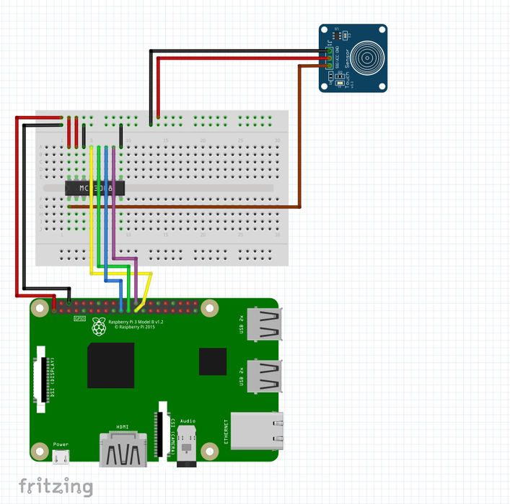
   * Using an MCP3008, The moisture sensor and sunlight sensor will all be plugged into this
   * This diagram applies to all sensors. Vcc and ground will correspond to red and black respectively. The brown wire goes into the MCP3008 input.
   * Each sensor will have an analog output, this should go into the MCP3008 input.
   * Your sensors may look different but should have at least those wire outs.
   * Sunlight goes into P0, moisture P1, reservoir P2
   * Please consult MCP3008 documentation to set it up correctly
2. Pump
   * Help from and images from: <https://dev.to/alanjc/water-your-plant-using-a-raspberry-pi-and-python-2ddb>
   * 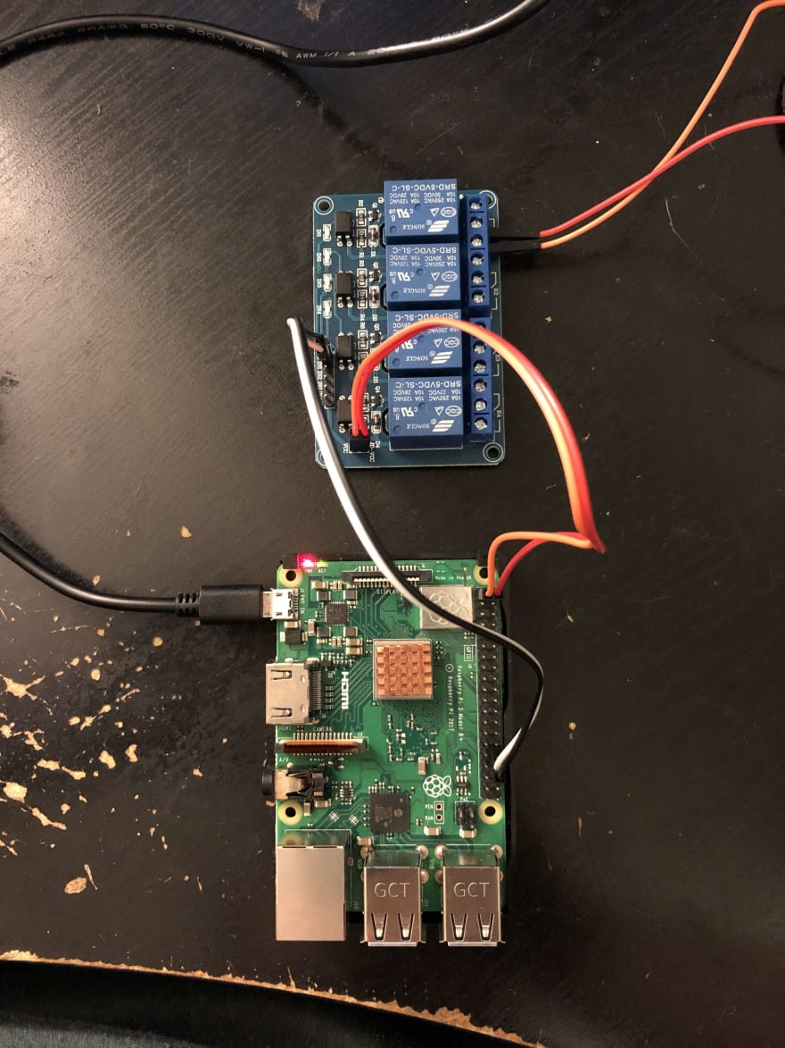
3. Software
   * Run the python program “main.py”
   * Any errors with libraries, do a pip install on them. It will be different for everyone what you need most likely.
   * Use “sensor_test.py” to test everything working correctly.
4. Config file
   * Change the config file to put the public ip of the server, username, password, database name, and port.
   * 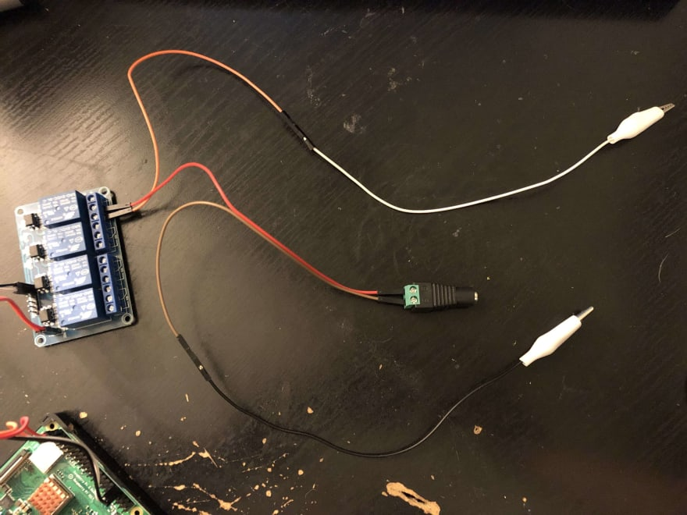
   * The white wire goes in this image goes to ground on the pump
   * The black wire goes to positive.
   * 12v power supply goes into the 12v power supply input device.
   * For more details, look at the linked article, it is what I used to set it up initially.